Mathematics Peer Tutoring Program will be taking place afterschool

The Mathematics Peer Tutoring Club has been responsible for promoting mathematics throughout the School and for organising tutors, who are very able mathematics students from years 10,11 and 12, to provide, once a week, one on one mathematics tuition for any student in years 7, 8 and 9 needing extra assistance with their maths.

In consultation with tutors and with students who take advantage of the maths help offered at the School there was a strong indication that these sessions should be offered after school instead of lunchtime so that students could attend more co-curricular activities that are offered at lunchtimes. This will also enable more students from Year 7-9 to access free one on one tuition with their maths.

As such, during this semester, the Peer tutoring program will now take place once a week afterschool alternating between Monday and Tuesday.
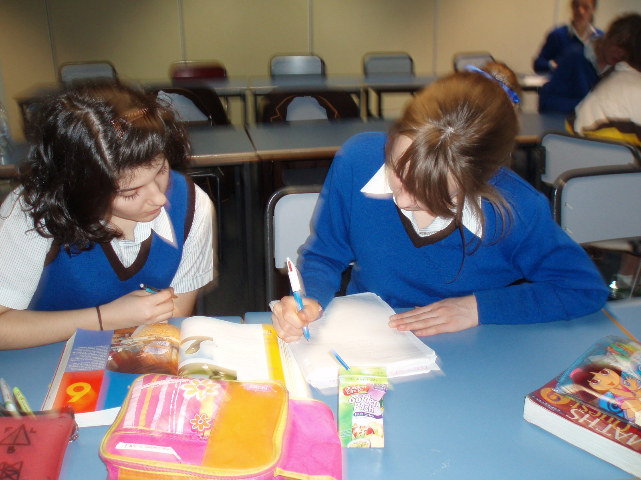

Students who need extra maths assistance or would like to review an assessment task are strongly encouraged to attend this free service.

Maths help sessions will take place afterschool from 3.50pm to 4.40pm
in room C205 on the following days:

Tuesday, 29 July 2008
Monday, 4 August 2008
Tuesday, 12 August 2008
Monday, 18 August 2008
Tuesday, 26 August 2008
Monday, 1 September 2008
Tuesday, 9 September 2008
Term Break
Monday, 13 October 2008
Tuesday, 21 October 2008
Monday, 27 October 2008

I look forward to seeing more students of the School taking advantage of this free service which is kindly offered by the Mathematics Peer Tutoring Club.

Angela Kotsiras
Head of Mathematic

